Chapter3: Machine Learning for causal Inference
3.1 Basic of causal Inference:
Main task - To estimate the outcome changes if another treatment had been applied.
An ex: From electronic data, we can only infer the treatment taken by the patient, but in order to assess what would happen if the patient took another medication or not at all, is difficult to observe.
Here we can use causal inference to predict the potential outcome for all treatment for every patient for all possible dosages .
3.1.1 Assumptions needed :
1. Stable Unit Treatment Value Assumption (SUTVA: It emphasizes on two points
First - Independence of each unit, that is, there are no interactions between units.(One patient's outcome will not affect the other
Second:
2. Ignorability : if two patients have the same background variable X, their potential outcomes should be the same whatever the treatment assignment and vice versa.
3. Positivity: Each unit has a non zeo chance of receiving the treatment.
For a person i, with outcome Y, Treatment W, covariates x
Yf = Observed outcome, Ycf - counterfactaul outcome.
Yf = wiyi(1) + (1-wi)yi(0), the second part is to capture the effect of not receiving the treatment.
For example if tretament was received so w-1,then:
Yf = y1(1), and if second part was not there then yf=0, which is wrong as the individual will have an outcome.
So here we will get the yf(for w-0) = yi(1)
ITE(i) = Yf -Ycf
ITE(i) = wiyi(1) +(1-wi)yi(0) - (wiyi(0) + (1-wi)yi(1))
ATE = Ex[E [yf(w=1,X=x) - E[y(w=0,X=x)
ATE = 1\N * average [yi(W=1) - yi(W=0)] = 1\N * average [ITEi]

ATT = 1\Nt * average [ITEi]
CATE = E[Y(w=1,X=x)] - E[Y(W=0,X=x)]

3.1.2 Confounders.
Now even though we calculated ATE, but this could be a spurious effect as there might be some variables, which affect both the treatment and outcome, which gives a biased estimate.
One such variable is age, which affects both the treatment and outcome .
Suppose we have a treatment group , with outcome mortality , who are diseased, which is elderly and there is a control group, who are diseased , but not mortal, as they are young. So the ATE is biased here in this example.
So we need to consider these variables, which are known as confounders.(Simpson’s Paradox)
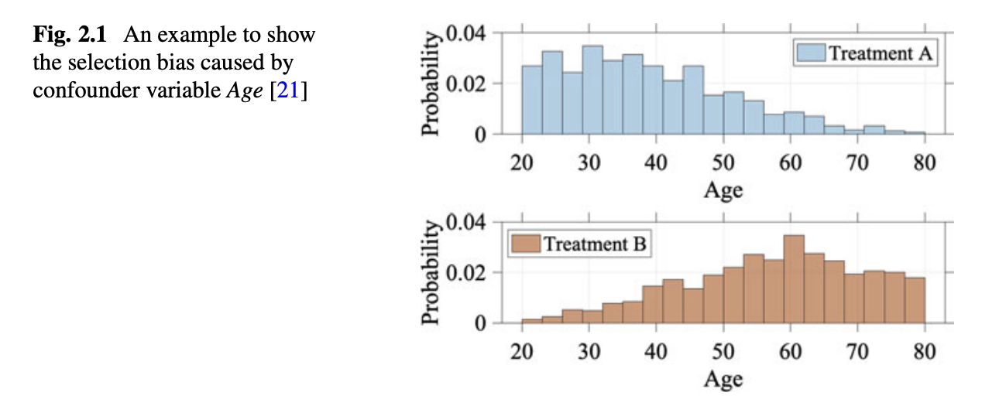

Note: Confounder variables affect units’ treatment choices, which leads to selection bias. In the medicine example, age is a confounder variable, so that people of different ages have different treatment preferences.

Handling of confounders is an important part of causal inference, and this is known as confounder adjustment.

Solution:
A) Suppose we have different age group, what we can do is find the ATE in each subgroup and multiply it with the probability in population: which is demonstrated by the equation:
ATE ˆ = x p(x)E[Y F |X = x, W = 1]− x p(x)E[Y F |X = x, W = 0]
Where p(x) - represents the robability of the background variables in X∗ over the whole population.
B) To address selection bias, we can make a pseudo population so the treated and the control group both are comparable.This can be done through different methods such as: re-weighting, matching, tree-based methods, confounder balancing, balanced representation learning methods, and multi-task-based methods.

3.2 Causal effect estimation methods:
3.2.1 Reweighting:
Due to the existence of confounders, the covariate distributions of the treated group and control group are different, which leads to the selection bias. One method of dealing with selection bias is reweighting -
3.2.1a Propensity-Score-Based Sample Re-weighting

PS - The propensity score which we discussed in the earlier chapter 2.
It is a balancing score (b(x)), W⊥ x|b(x) , where W is the treatment assignment and x is the background variables.
First we calculate the PS for the treated and the non treated , then use the inverse probability to calculate the weights and then calculate the ATE
The propensity score can be used to balance the covariates in the treatment and control groups and therefore reduce the bias.
However, in practice, the correctness of the IPW estimator highly relies on the correctness of the propensity score estimation.Therefore we have DR(doubly robust methods), which combines the propensity score weighting with the outcome regression, so that the estimator is robust even when one of the propensity scores or outcome regression is incorrect (but not both).
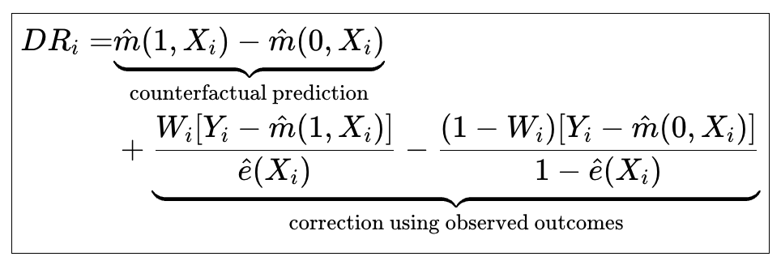

AIPW
│
┌───────┴────────┐
↓ ↓
Outcome model Propensity model
│ │
↓ ↓
Predict Y(1), Y(0) e(X)
│ │
└───────┬────────┘
↓
Residual correction
↓
ATE

3.2.2 Confounder balancing:
A limitation of conventional propensity-score-based methods such as IPTW and AIPTW is that not all observed covariates necessarily play the same causal role. Some variables may be true confounders that need to be accounted for in the treatment-assignment mechanism, whereas others may be predictive of the outcome without being confounders. Still other variables may be irrelevant to both treatment assignment and outcome.
When sufficient subject-matter knowledge or prior causal information is unavailable to make this distinction reliably, a data-driven approach can be useful. Data-Driven Variable Decomposition (D2VD) addresses this problem by jointly identifying and separating observed variables into different roles—confounders, adjustment variables, and irrelevant variables—while estimating the causal effect.

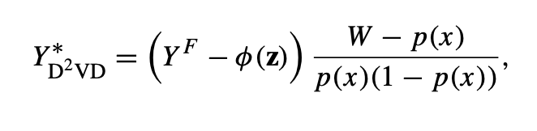
Now let us try to understand it with examples:
In AIPW , we assume the variables added are all confounders, but in D2VD, we want the algorithm to find the confounders, the adjustment variables,and those which are irrelevant.

Now D2VD introduces two sets of components, alpha and beta , which are the outcome coefficients, and the PS/treatment coefficients.
And then
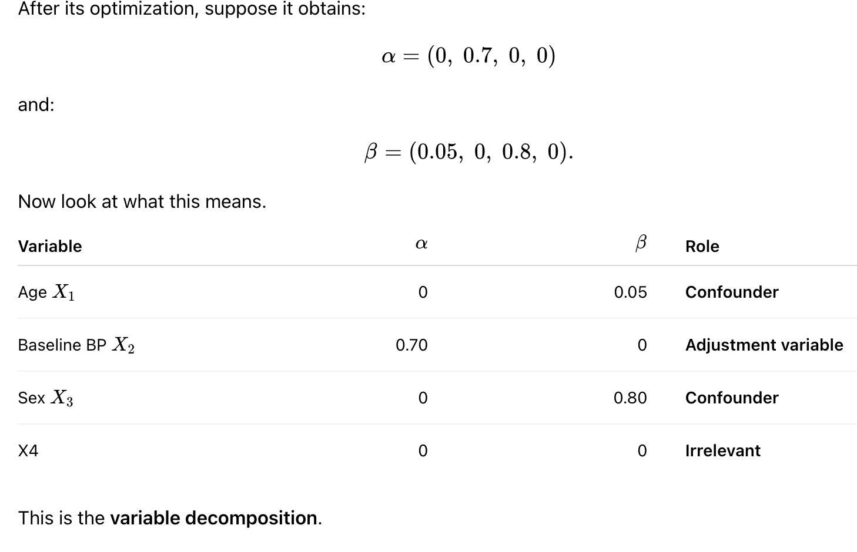
Now Z = X2,
So if we have suppose Y=150, Z = X2 = 140, Y-Z = 10,
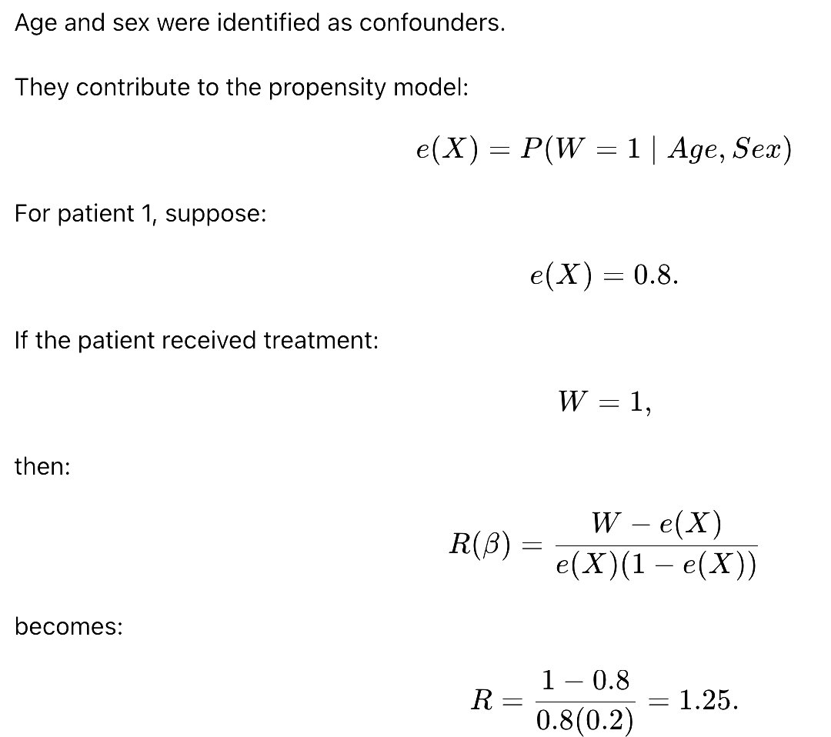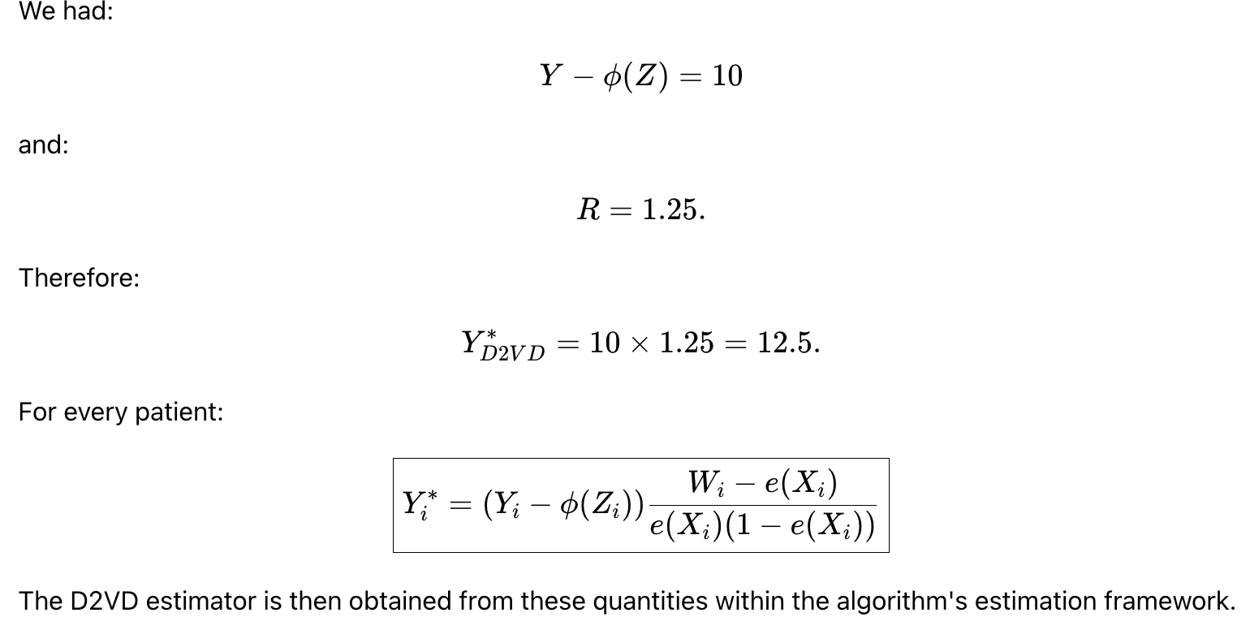
3.2.3 Stratification
Also known as blocking or subclassification, tell us to compare the treated and untreated in an homogenous subgroup.
Therefore, the units in the same subgroup can be viewed as sampled from the data under randomized controlled trials.
Based on the homogeneity of each subgroup, the treatment effect within each subgroup (i.e., CATE) can be calculated through the method developed on randomized controlled trials (RCTs) data.
After obtaining the CATE of each subgroup, the treatment effect over the interested group can be obtained by combining the CATEs of subgroups belonging to that group.

q(j ) = N (j ) N is the portion of the units in the j -th block to the whole units.
Then ,
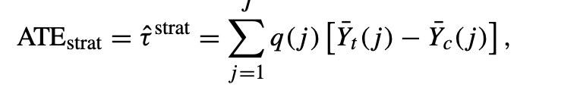

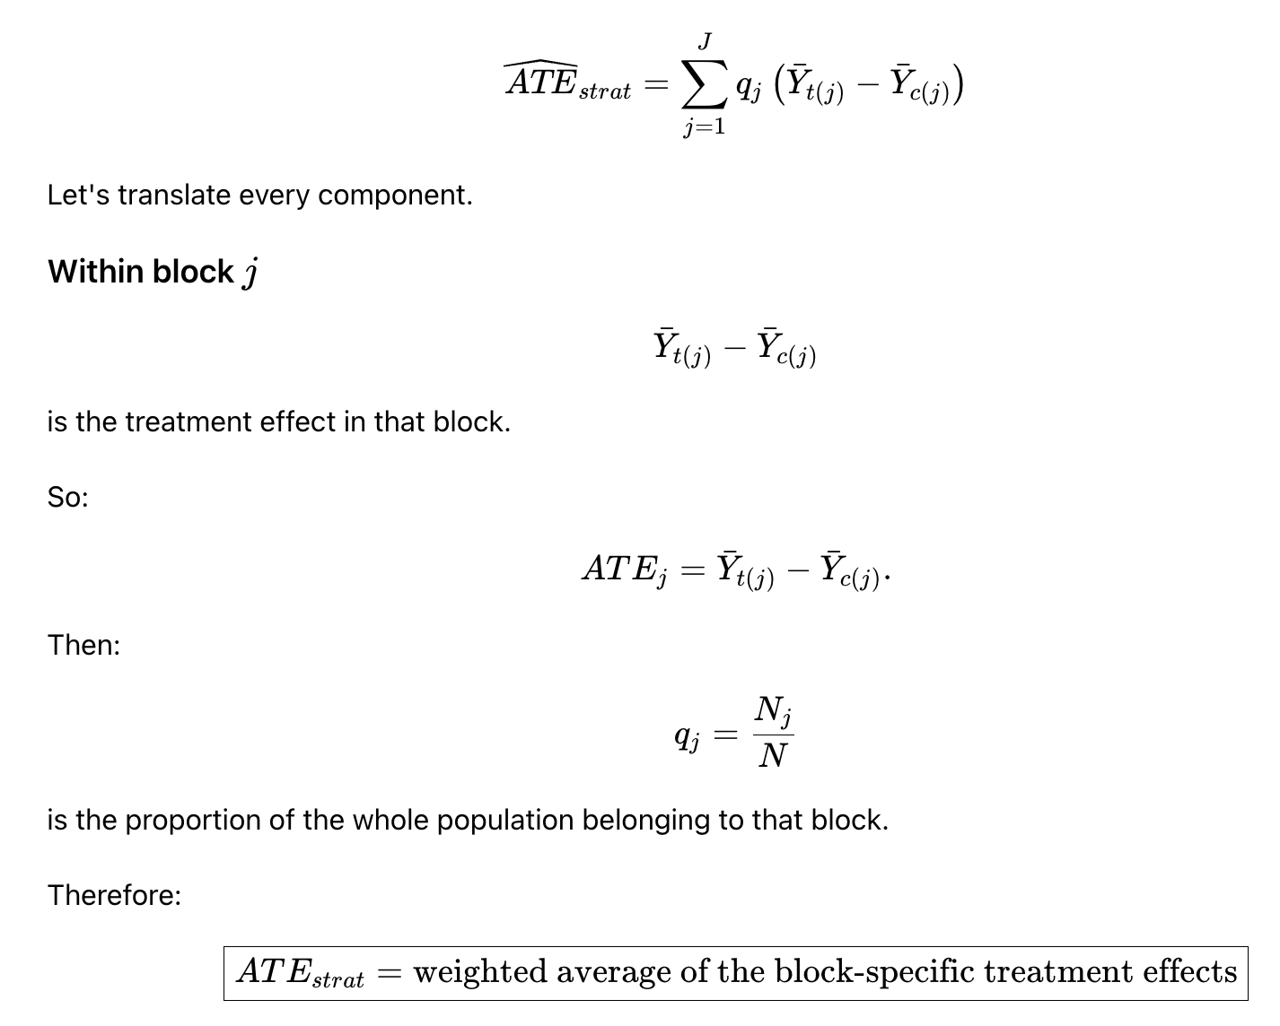
3.2.4 How to create block:
1. Equal frequency block - The equal frequency approach splits the block by the appearance probability, such as the propensity score, so that the covariates have the same appearance probability (i.e., the propensity score) in each subgroup (block). The ATE is estimated by the weighted average of each block’s CATE, with the weight as the fraction of the units in this block.
Problem: High variance due to insufficient overlap.
To reduce it , the blocks are re-weighted by the inverse variance of the block-specific treatment effect.
But this might reduce variance but increase estimate bias.
3.2.5 Matching
Matching-based approaches provide a way to estimate the counterfactual and, at the same time, reduce the estimation bias brought by the confounders.
For an individual (i), only one potential outcome is observed. If (Wi=1), the observed outcome is (Yi(1)), while (Yi(0)) is unobserved. If (Wi=0), (Yi(0)) is observed and (Yi(1)) is unobserved. Matching estimates the missing potential outcome using one or more similar individuals from the opposite treatment group.
For example, if an individual receiving treatment has age, sex, disease severity, and other baseline characteristics similar to an untreated individual, the untreated individual's outcome can be used as an estimate of what might have happened to the treated individual in the absence of treatment.
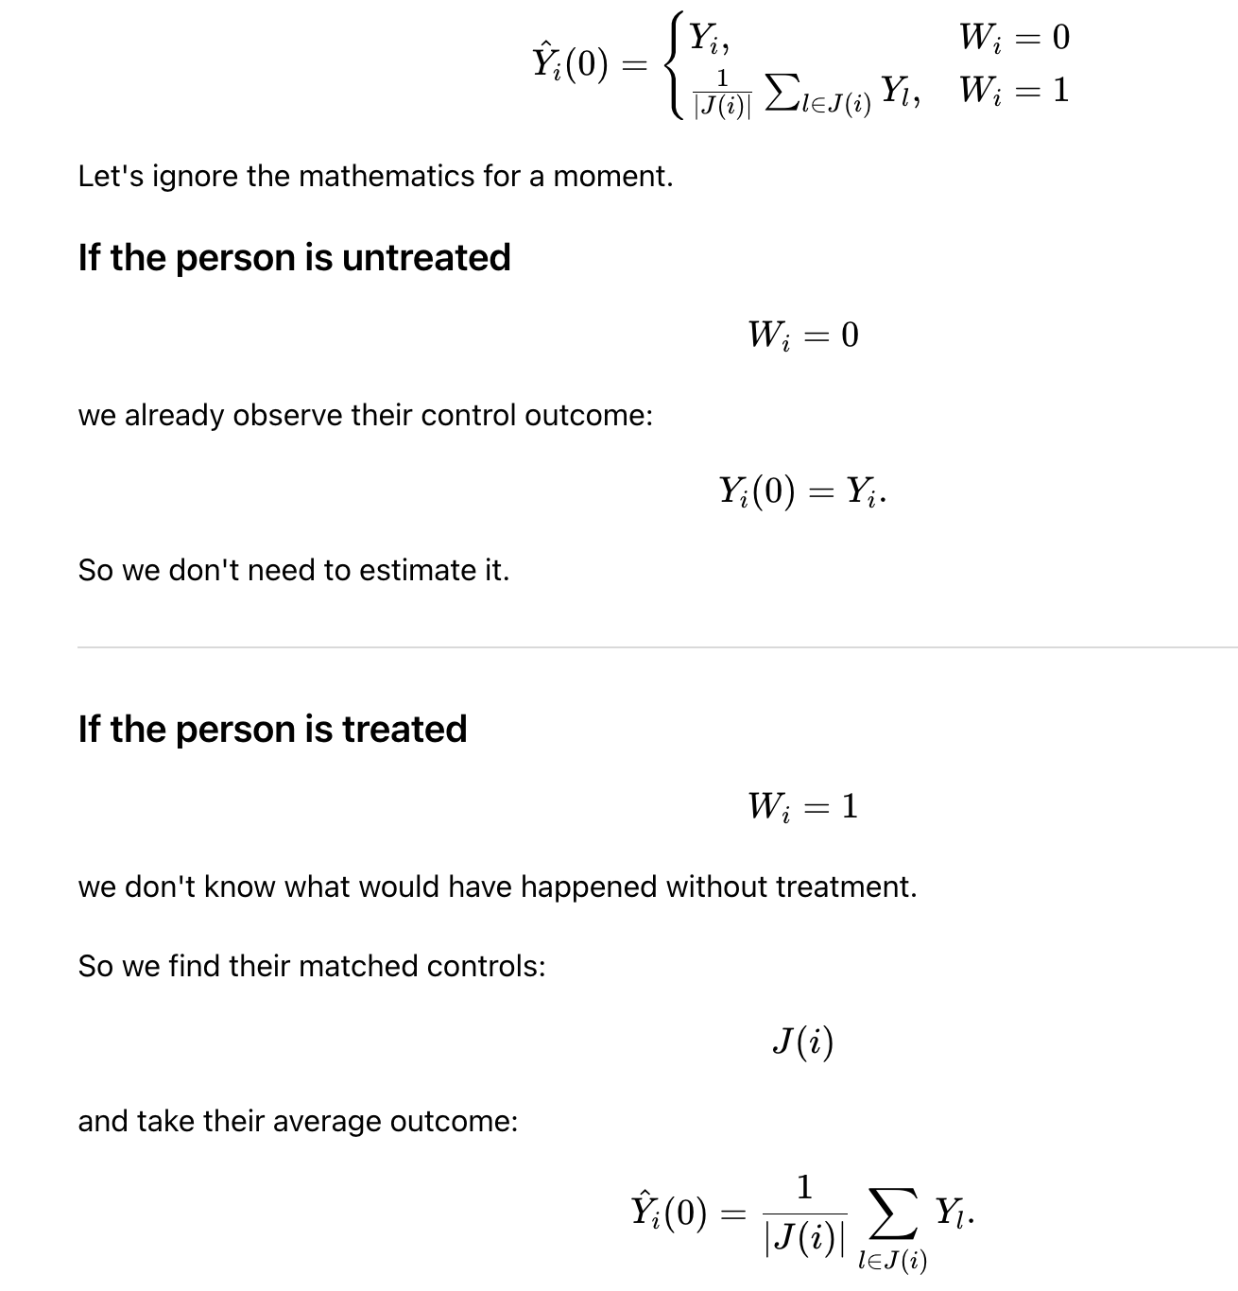
So the equation just simply says:
For a treated person, use the matched untreated people to estimate their missing control outcome.
Matching and Confounding: Matching helps with confounding, as it balances the groups with the measured covariates.
How to decide who is similar?
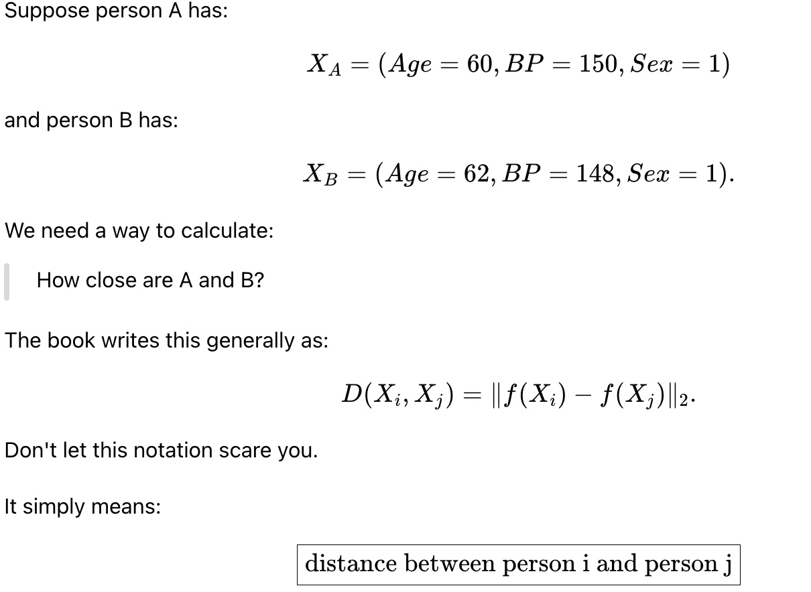
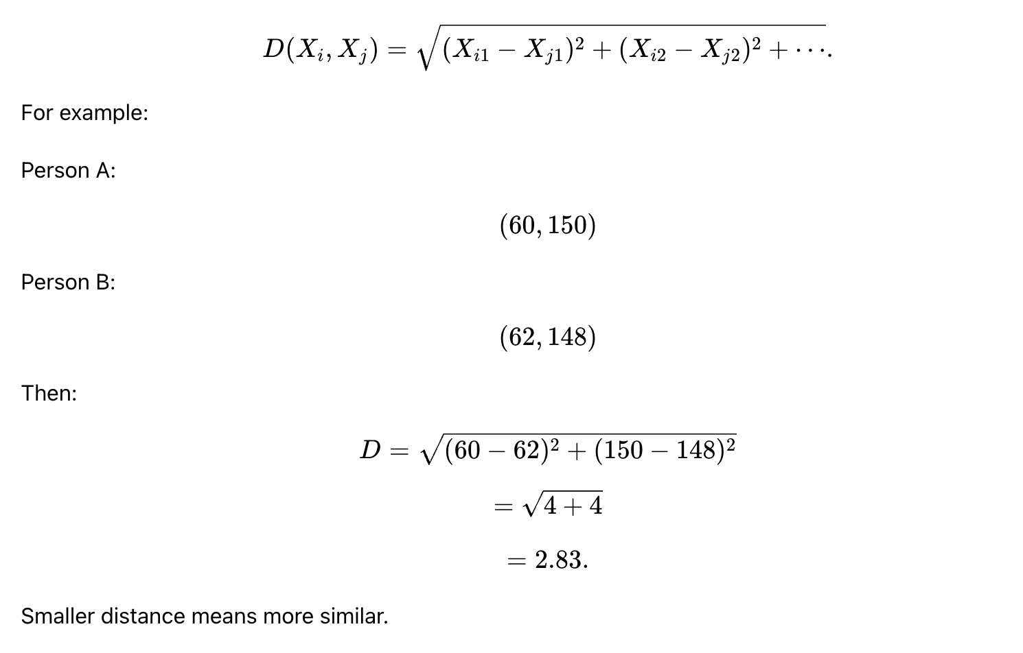
The problem is suppose we have variables with different scales, then the variables with large numerical scales can dominate the distance calculation.

Propensity score as a distance metric:
Instead of matching on similar covariates, we try to match on similar or nearest propensity scores:
Under the assumptions of causal inference, individuals with similar propensity scores have similar distributions of observed covariates.
Therefore: ei​≈ej​, means they have similar treatment-selection profiles.
We can also do : PS similarity + Covariate similarity .
Selection of variables for matching
Variables used for matching should generally be measured before treatment and should be selected based on the causal structure and subject-matter knowledge. Important pre-treatment confounders and variables associated with the outcome can be useful for improving comparability between treatment groups.
Post-treatment variables should generally not be included in matching because they may be affected by the treatment. Conditioning on such variables can block causal pathways or introduce other forms of bias. Instrumental variables should also not be included automatically, particularly when they strongly predict treatment but have little relationship with the outcome, because they can worsen variance and positivity problems.
Matching therefore differs from simply matching on every available variable. The goal is to create a comparable population using variables that are appropriate for causal adjustment.

Role of matching in causal inference
Matching can be viewed as a design-stage approach to confounding control. Rather than directly modeling the entire population, it attempts to construct a subset or weighted comparison in which treated and untreated individuals are sufficiently comparable with respect to measured pre-treatment covariates.
However, matching does not eliminate unmeasured confounding. Its validity still depends on assumptions such as consistency, conditional exchangeability given the measured covariates, and adequate positivity/overlap. Consequently, successful matching should be followed by diagnostic assessment of balance and overlap rather than assuming that matching itself guarantees an unbiased causal estimate.

